Curriculum Vitae

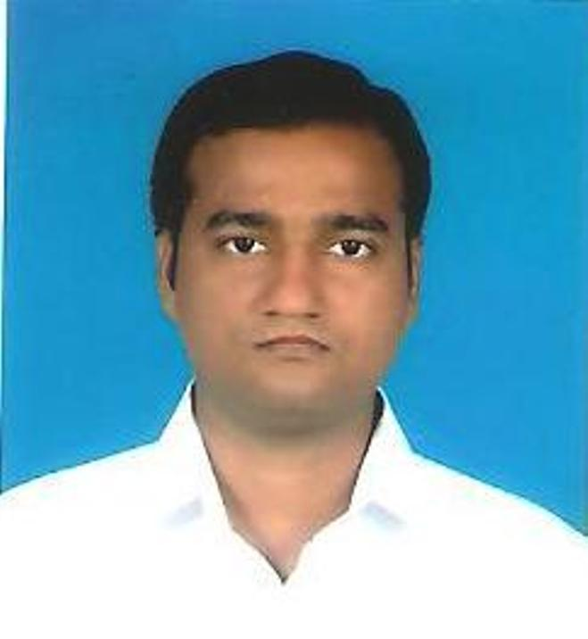
TARKESHWAR SINGH
35 Jeliapara,
Khardah,
Kolkata – 700117,
West Bengal

OBJECTIVE

Seek an opportunity to work in prestigious organization.

I would welcome an opportunity to consolidate and expand my knowledge leading to a career growth and positive contribution to the organization. I perform my job diligently and sincerely.

WORK EXPERIENCE

- Worked as an article trainee with S. Swarup & Co a practicing Firm of Chartered Accountants from August 16, 2007 to September 05, 2011.

- Worked with Kamal Khaitan & Associated (Chartered Accountants) from January 2012 to August 2012.

- Worked with Keshar Multiyarn Mill Ltd. (Yarn Manufacturer) from September 2012 to September 2014.

- Working with CRI Limited from October 2014 onward as a Sr. Manager – Accounts & Finance.

During the above period, I have gained an insight into the following matters:

- Financial Work: Preparation, Examination and Analysis of Financial Statement, Certification of receivable, reconciliation of parties ledger, preparation of report under Income Tax, preparation of details for assessment proceeding, handling of accounts of manufacturing and other company.

- Overall Experience: My experience has given me a crystal clear picture into various aspects of Finalisation of Account under Revised Schedule VI, Statutory Audit, Tax Audit, Credit Rating, Limited Review, Corporate Governance of the listed company and Public and private companies as applicable. This has widened my perspective and has given me a sense of understanding of accounting from a practical point of view. The interaction with my seniors at different levels has provided me an opportunity to build upon my communication skills and understand the working environment in new light.

EDUCATION

ACADEMIC CREDENTIALS

Year of Passing | Examination | University / Board/Council | Institution | Performance
2006 | B.COM (Hons.) | Calcutta University | Umeschand college | 60%
2003 | CLASS XII | W.B.C.H.S.E | Englo Vernacular High School | 59%
2001 | CLASS X | W.B.B.S.E | S.K.N.P. High School | 53%

PROFESSIONAL CREDENTIALS

Term of Passing | Examination | Institution | Performance
MAY, 2007 | CA PE-II | ICAI | 57%
Nov, 2011 | CA FINAL | ICAI | 52%
Dec, 2011 | EXECUTIVE (M-1) | ICSI | 54%

SKILLS

COMPUTING SKILLS

- Computer Proficiency:
- Completed 250 hours Compulsory Computer Training Programme conducted by ICAI.
  - Hands on experience in MS-Office, MS-Windows, Internetworking, Tally and SAP B1.
  - Familiar with the use of E-Commerce in modern corporate environment.

CORPORATE COMMUNICATION

- Completed 15 days General Management and Communication Skill programme conducted as per the regulation of the ICAI
- Good interpersonal abilities and comfortable with both oral and written communication.
- Fluent in English, Hindi & Bengali language.

PERSONAL DETAILS

- Date of Birth : 26th September, 1985
- Father’s Name : Mr. Saligram Singh
- Marital Status : Single
- Nationality : Indian
- Contact Details : Mobile: +91 9088955007
E-mail: ca.tsingh12@gmail.com
- Hobbies : Reading newspaper, watching TV, spending time
with friends.

Assignments Handled

Statutory Audit & Tax Audit
- Usha Martin Educations & Solutions Ltd. (Listed)
- Lexus Motors Ltd.
- Autotech Services Ltd.
- Super Diamond Nirman Ltd.
- Alcove Construction Pvt. Ltd.
- SBIW Steels Pvt. Ltd.
- Pushpak Dealcom Pvt. Ltd.
- P P Suppliers Pvt. Ltd.
- Diamond Nirman Enterprises (Partnership)
- GNG Exports (Partnership)

Corporate Experience
- Associated with scrutiny assessment under Income Tax
- Associated with Credit Rating Work
- Finalisation of Accounts under revised Schedule VI annually & monthly
- Stock Statement for Bankers
- Assessment & Appeal of Income Tax, VAT & CST
- Handling the Statutory Auditor and Internal Auditor
- Making coordination with staffs
- Statutory compliance, Licenses, schedules for MIS, reconciliation with Branches, and parties, preparation of profit Targets,
- Liaison with Bank for Bank Guarantee.
- Associated with SAP implementation to the extent account involved

